Turiba University
Ekhlas Rayees Khan

Downloading and Installing IntelliJ IDEA
PROFESSIONAL BACHELOR THESIS

Computer System

Author: Ekhlas Rayees Khan
Thesis Advisor: Jānis Pekša

Riga,2025

Introduction
IntelliJ IDEA is the leading Integrated Development Environment (IDE) built for professional Java and Kotlin development. Designed to maximize developer productivity, it also places the highest priority on security and privacy.

Downloading and Installing IntelliJ IDEA
Follow these steps to successfully download and install the IntelliJ IDEA Integrated Development Environment (IDE):
- Open the official JetBrains website.

- Navigate to the IntelliJ IDEA homepage.
- Choose the version for your operating system (Windows, macOS, Linux).
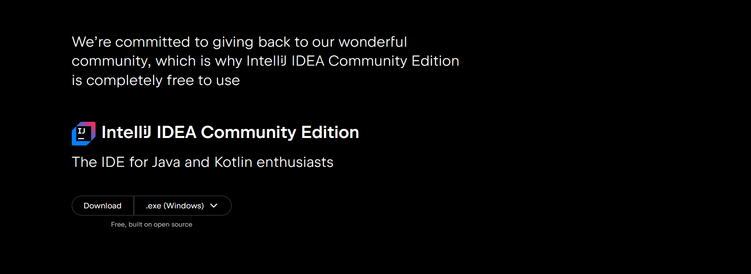

- On the IntelliJ IDEA homepage click “Download” button.

- Select your edition: Choose between the free Community Edition or the Ultimate Edition (paid, with additional professional features).
2. Complete the Installation
- Once the download is complete, run the installer file.
- Follow the setup wizard, ensuring you check all necessary configuration options (like creating a desktop shortcut or setting file associations). 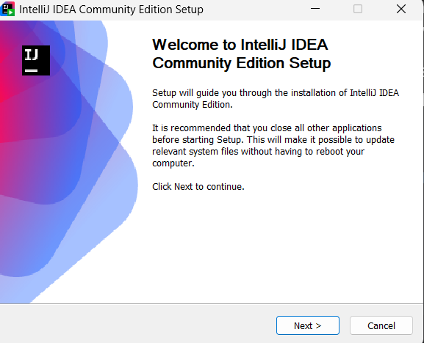

3. Initial Setup and Configuration
- After the installation finishes, launch IntelliJ IDEA.
- Create a new project.
- The IDE will prompt you to install a Java Development Kit (JDK) if one is not detected. Select the appropriate JDK version for your project and let the IDE install it.

4. Ready to Code
- Your downloading and installation process is complete.
- You can now create a public class (e.g., public class Practice) and begin writing your Java or Kotlin code.
- Here’s a practice sample code inside IntelliJ with the public class, “practice”.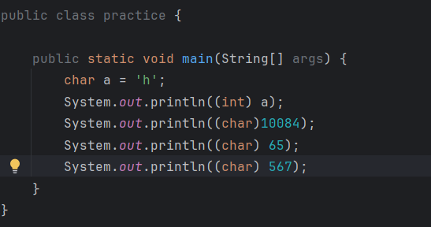

- The downloading and installation process is complete, and your IDE is ready.

Conclusion
- IntelliJ IDEA provides a seamless process for users to download, install, and begin working on their development projects.
- A proper installation and initial setup ensures a smooth and efficient workflow for developers working with multiple programming languages and frameworks.

